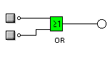 | 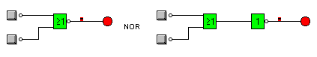
$$F=a+b$$ | $$F=\overline{a+b}$$
  a | b | S
  0 | 0 | 0
  0 | 1 | 1
  1 | 0 | 1
  1 | 1 | 1
  a | b | S
  0 | 0 | 1
  0 | 1 | 0
  1 | 0 | 0
  1 | 1 | 0
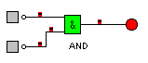 | 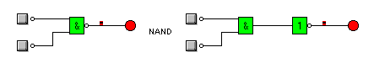
  a | b | S
  0 | 0 | 0
  0 | 1 | 0
  1 | 0 | 0
  1 | 1 | 1
  a | b | S
  0 | 0 | 1
  0 | 1 | 1
  1 | 0 | 1
  1 | 1 | 0
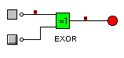 | 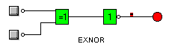
  a | b | S
  0 | 0 | 0
  0 | 1 | 1
  1 | 0 | 1
  1 | 1 | 0
  a | b | S
  0 | 0 | 1
  0 | 1 | 0
  1 | 0 | 0
  1 | 1 | 1

